***WHAT IS ESOPHAGEAL ATRESIA?***

*Esophageal Atresia (EA)* is defined as an interruption of the esophagus. It can occur with or without a Tracheo-esophageal fistula (TEF).

A *fistula* is an abnormal passageway between two structures that do not normally connect.

Therefore, a tracheoesophageal fistula (*TEF)* is an abnormal link between the trachea (where air goes in) and the esophagus (where food passes).

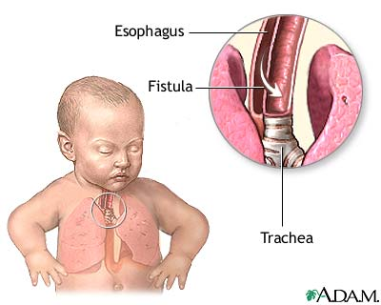

***WHO GETS & WHAT CAUSES EA and/or TEF?***

The majority of these cases occur sporadically, that is, at random. A small percentage of cases are linked with chromosomal abnormalities. It is relatively common, as it occurs in 1 in 2500-3000 births.

***WHAT ARE THE SIGNS & SYMPTOMS?***

Some possible signs include:

* During the pregnancy, there may be an increase in amniotic fluid in the amniotic sac (also known as polyhydramnios).
* Once born, the baby may present with trouble swallowing his/her saliva and bubbly saliva accumulating at the mouth.
* The newborn may have rattling respiration, episodes of coughing, choking, and appear cyanotic (bluish tint of the skin).
* The baby may also present with an enlarged abdomen as a result of air building up in the stomach indicating the presence of a fistula.

***WHAT ARE THE DIFFERENT TYPES OF EA/TEF?***

Type A: EA without a fistula.

Type B: EA along with a fistula present on the *upper* portion of the esophagus (rare).

Type C: EA along with a fistula on the *lower* portion of the esophagus (most common).

Type D: EA with a fistula to *both* the *upper and lower* segments of the esophagus (rare).

Type E: A fistula is present *without* an EA (also called an H type fistula).

This image shows the most common types (type C) to least common types (type D):

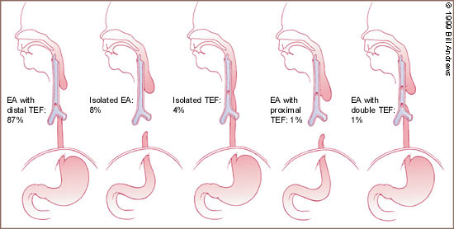

**C A E B D**

***CAN THERE BE ASSOCIATED PROBLEMS?***

Yes. Anomalies occur in 50% of the cases. They often fall under the VACTERL association:

* **V**ertebral
* **A**norectal
* **C**ardiac
* **T**racheo Esophageal
* **R**enal
* **L**imb deficits

***HOW IS EA/TEF TREATED?***

⮊ First, if an atresia is present, a surgery called an *anastomosis* is done. This includes sewing the upper and lower portions of the esophagus together.

⮊Sometimes the two portions are too far away from each other. In that case, the surgical repair may have to wait. Meanwhile, the child may be fed through a gastrostomy tube (tube directly inserted into the stomach for feedings).

⮊A tube may be inserted into the upper portion of the esophagus to suction the accumulation of saliva.

⮊ If a TEF is present, surgery is performed to remove the fistula.



***WHAT ARE THE LONG-TERM COMPLICATIONS?***

* Following the surgery, the site of repair may become narrowed (stenosis). This may need to be stretched (dilatation).
* Gastroesophageal reflux (GER) is a common complication. This happens when the contents of the stomach go back up the esophagus. This is usually treated with medication.
* There is usually a structural abnormality of the trachea, known as *tracheomalacia,* which makes it prone to collapse.This results in a typical “barking” cough. Occasionally it may result in severe “blue spells”, which would require investigation and treatment.
* Food & liquids may progress more slowly down the esophagus (dysmotility).
* Respiratory complications may persist.

# The Team at the Montreal Children’s

All children diagnosed with EA will be followed by the Esophageal Atresia Multidisciplinary Team of the Montreal Children’s Hospital upon discharge from the neonatology unit. The team meets on a regular basis to determine which treatment interventions should be done to ensure the best quality of care for your child!

The team consists of:

* Gastroenterologist
* Surgeons
* Pediatrician
* Respirologist
* Occupational Therapist
* Nurse
* Dietician
* Others as needed

Here are some interesting resources that may help.

* [**http://www.afao.asso.fr/**](http://www.afao.asso.fr/)
* [**http://www.tofs.org.uk/**](http://www.tofs.org.uk/)
* [**http://www.eatef.org/**](http://www.eatef.org/)
* [**http://www1.umn.edu.eatef/**](http://www1.umn.edu.eatef/)

Esophageal Atresia-Tracheo-Esophageal Fistula (EA/TEF)Clinic at the

**Montreal Children’s Hospital**

Parent Information Booklet

**L’Hôpital de Montréal pour enfants**

**The Montreal Children’s Hospital**

Centre universitaire de santé McGill

McGill University Health Centre

